Name: Shreyans Tatiya
Class: E-2
Roll no: 16010123325

Understanding India
The Idea of India: One of the things I noticed on this field trip is that most of the population’s idea of India is based on the current scenario. While in class, we explored what it means to be Indian, but the working-class population we interacted with did not express philosophical views on this. Instead, most people's understanding of our country was shaped by the political atmosphere. However, this itself is a defining aspect of being Indian—if you were to ask anyone about their idea of India, politics would likely be the first thing they mention along with the social and financial status.

Sweeper
Name: Vijay Kumar
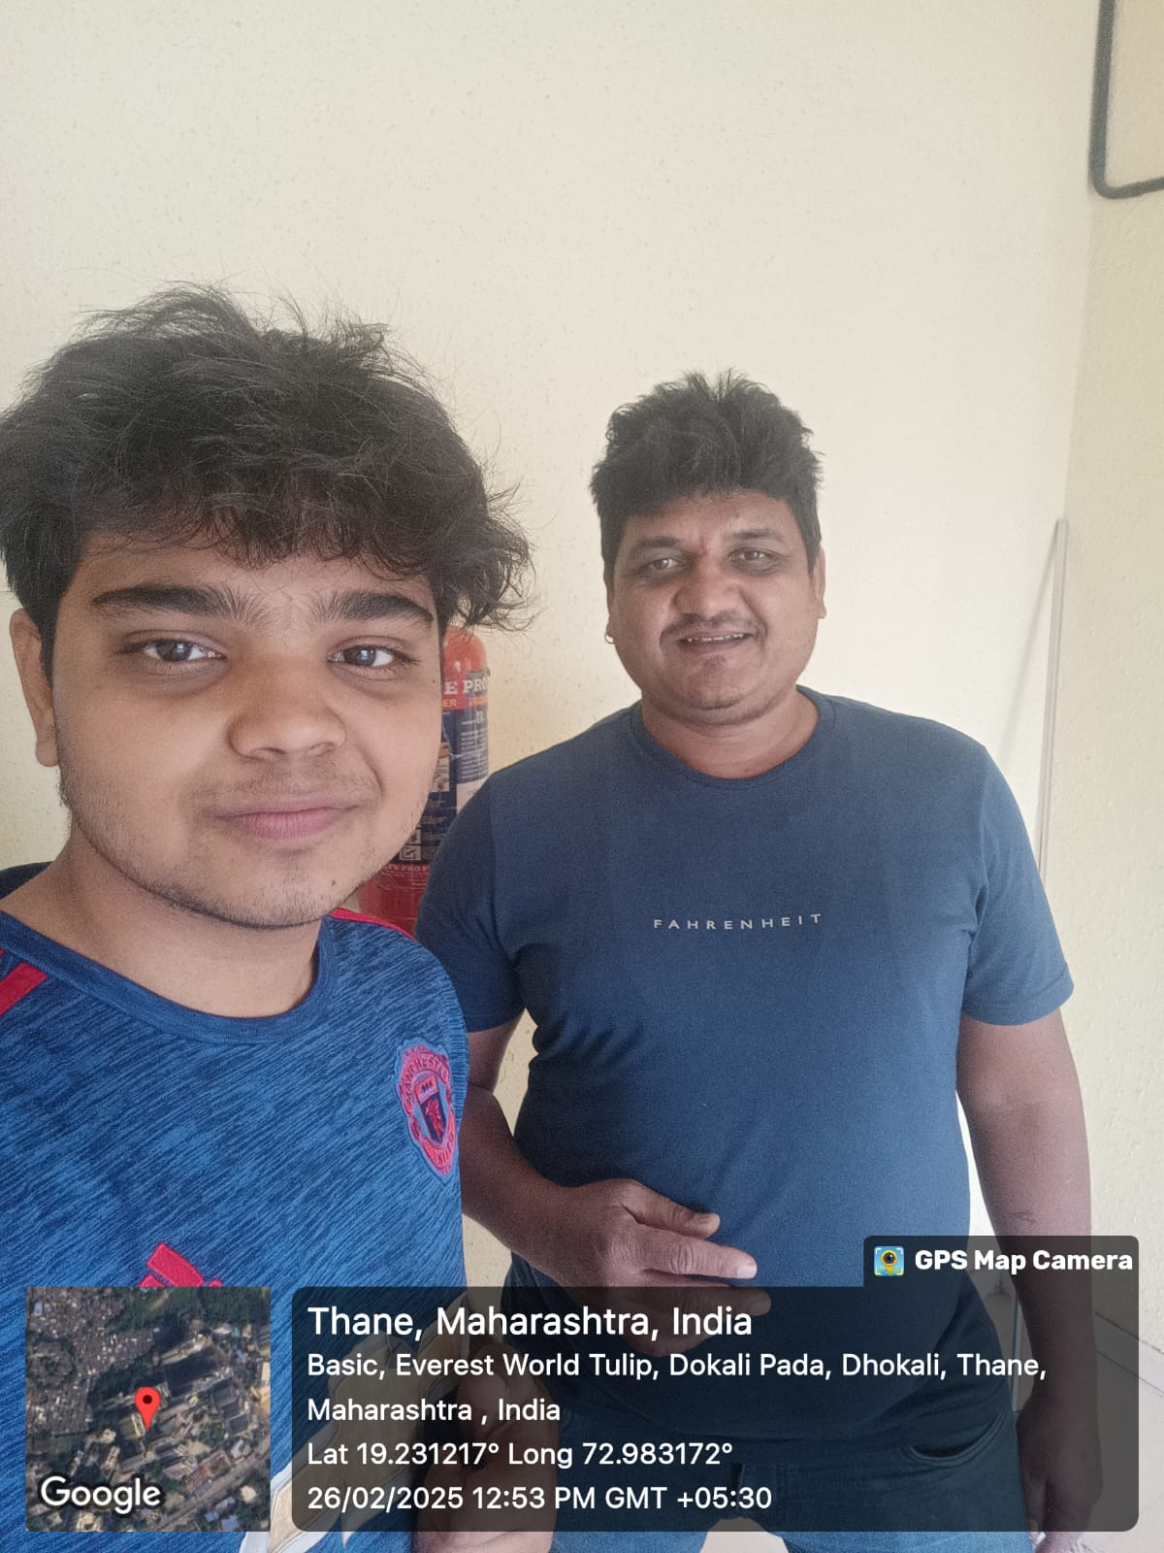
Despite possessing an undergraduate degree, Vijay struggled to secure employment in his field, ultimately taking up work as a sweeper. His concerns extended beyond personal economic hardship—he emphasized the need for stringent legislation against crimes such as sexual violence. He argued that India’s progress must be accompanied by comprehensive legal reforms ensuring women’s safety and social justice. He also expressed frustration at the lack of opportunities for individuals with education but no social connections or financial backing.
Analytical Viewpoint: Vijay’s concerns shed light on two interrelated issues: underemployment despite higher education and gaps in legislative frameworks addressing gender-based violence. His perspective highlights that socio-economic development must be accompanied by robust policy interventions that ensure opportunities are accessible to all, not just those with privilege.
Interview Voice Recording

Security Watchman
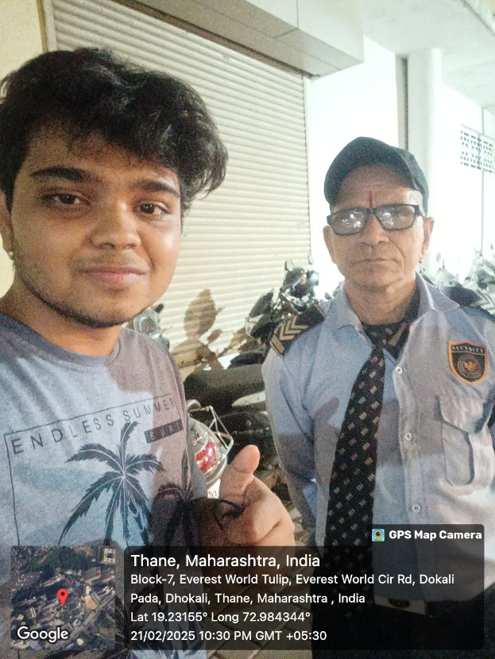
Name: Ramesh Yadav
Ramesh articulated a sense of frustration regarding his financial circumstances. Aspiring for upward mobility, he found himself constrained by his limited formal education. He expressed the need for more government intervention in providing well-compensated employment opportunities for individuals from similar socio-economic backgrounds. His perspective on India was introspective—he desired a nation that would facilitate social mobility and offer economic stability to the middle class. He emphasized that while the country is making advancements in various fields, individuals like him still struggle to make ends meet. He believes that education plays a crucial role in breaking the cycle of poverty but acknowledges that not everyone has the means to access quality education. His frustration stems from the lack of job security, rising living costs, and the perception that policies often favor the elite while neglecting the working class.
Analytical Viewpoint: Ramesh’s reflections underscore the aspirations and frustrations of a significant portion of India's working class. While there is an evident drive for progress, structural constraints perpetuate economic stagnation, creating a cycle of unfulfilled aspirations. His perspective is a reminder that economic growth at the macro level does not always translate to improved livelihoods for all citizens. For India to truly develop, policies must ensure inclusivity and address the financial struggles of those at the grassroots level.
Interview Voice Recording
Policeman 1
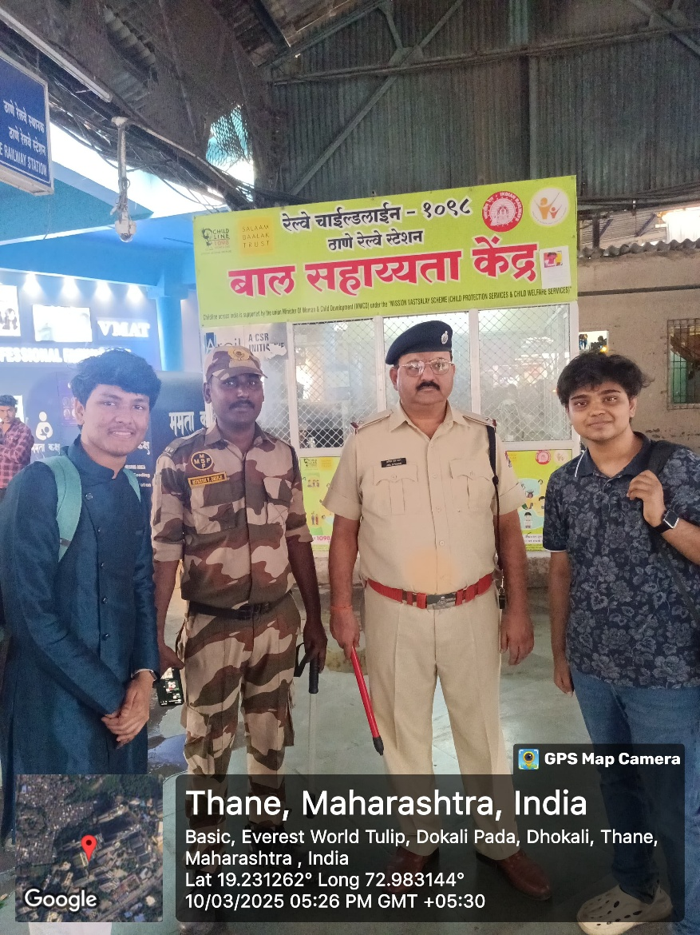
Name: Rajiv Sharma
Rajiv had a pragmatic view of India. He acknowledged the country's rapid development but pointed out that law enforcement still faced numerous challenges, from understaffing to bureaucratic inefficiencies. He believed that while India was progressing, systemic reforms in policing and judiciary were crucial for true modernization. He highlighted the difficulties faced by police officers, including long working hours, lack of resources, and political interference in law enforcement. He emphasized that for India to become a safer country, law enforcement agencies need better training, advanced technology, and stronger accountability mechanisms.
Analytical Viewpoint: Rajiv’s insights emphasize that economic growth must be accompanied by institutional reforms. While infrastructure and digitalization are improving, governance efficiency remains a critical issue. His perspective provides an insider's view of the challenges within law enforcement, reinforcing the need for holistic development that includes social and institutional progress.

Watchman & Shop Vendor

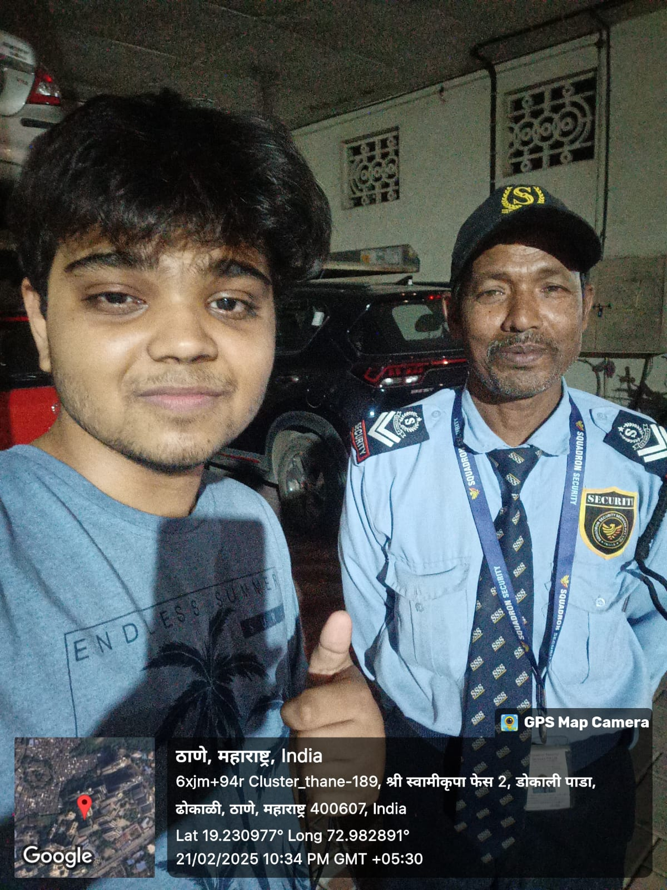
Name: Ashok Patil
Ashok presented a contrasting viewpoint. He exuded confidence in India's post-2014 development trajectory, attributing the nation’s progress to its current political leadership. An ardent supporter of Narendra Modi and Yogi Adityanath, he underscored the importance of a positive national outlook, arguing that public perception is integral to India’s continued growth. He believes that strong leadership is necessary for the country to continue on its path of progress and modernization. According to him, the infrastructural developments, increased digitalization, and policies aimed at economic growth have significantly improved India's global standing. He also mentioned that schemes like Jan Dhan Yojana and Ujjwala Yojana have benefited the lower-income groups, providing them with better financial and social security.
Analytical Viewpoint: Ashok’s perspective exemplifies the influence of political leadership on public sentiment. His faith in governance reflects the widespread belief that economic and infrastructural advancements are contingent on strong leadership. However, his view also highlights the role of political allegiance in shaping perceptions of national progress. While he sees positive change, others in different economic situations may not share the same level of optimism.
Interview Voice Recording
Cab Driver
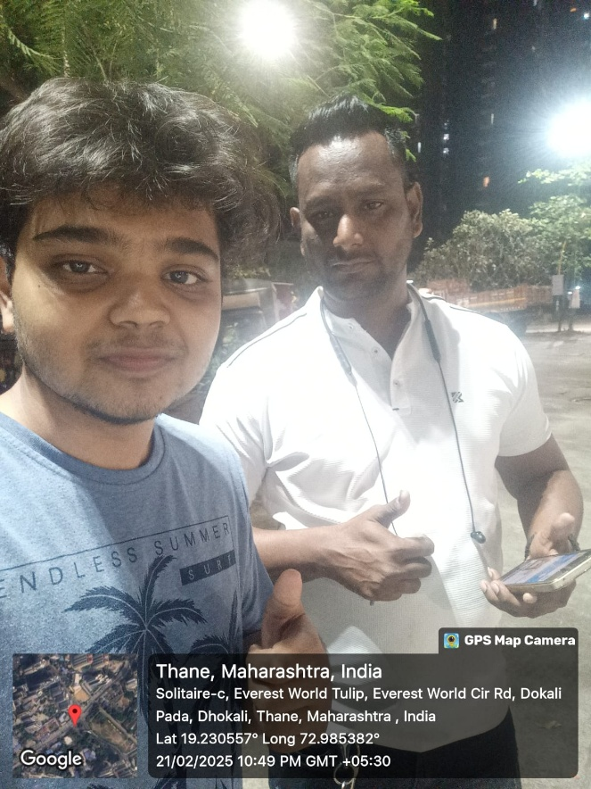
Name: Rajesh Verma
Rajesh had a nuanced perspective on India’s economic landscape. While he acknowledged improvements in infrastructure and digitalization (such as the proliferation of UPI), he was critical of rising inflation and fuel prices, which directly impacted his livelihood. He viewed these economic challenges as counterbalancing the benefits of infrastructural progress. He explained that while some aspects of daily life have become more convenient, others have become financially burdensome.
Analytical Viewpoint: Rajesh’s observations highlight the dual nature of economic development—while technological advancements improve accessibility, macroeconomic factors such as inflation impose financial strain on the lower and middle classes, creating a complex dynamic of progress and hardship.

Policeman 2
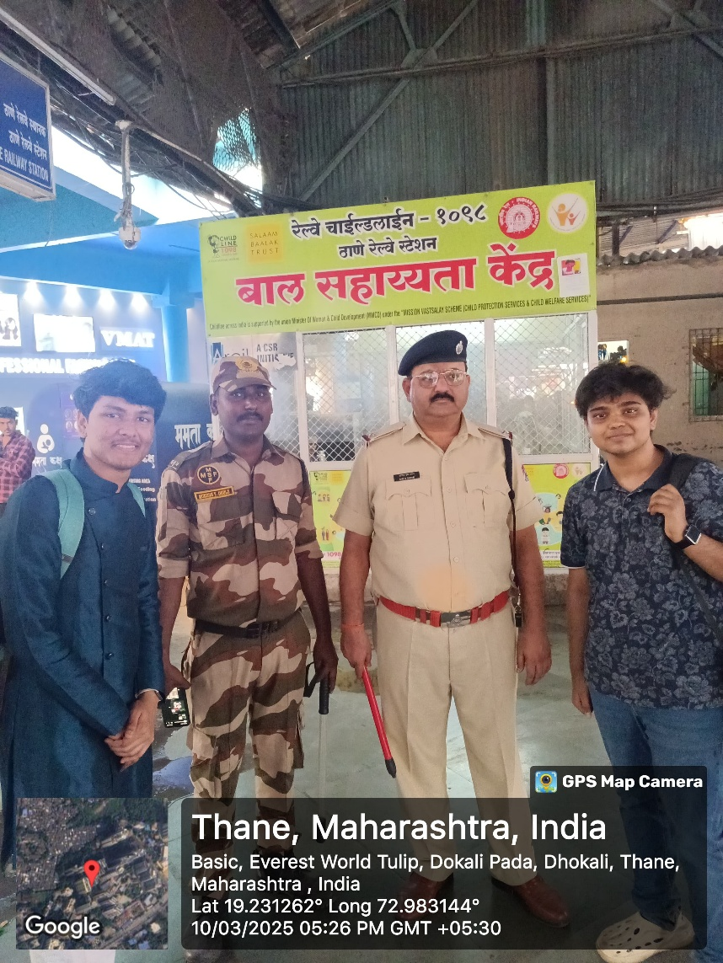
Name: Suresh Thakur
Suresh had a more optimistic view. He believed that crime rates were decreasing due to technological advancements in law enforcement, such as surveillance systems and digital policing. However, he agreed that social issues, particularly crimes against women, required stronger preventive measures and public awareness campaigns. He pointed out that while India has made progress in implementing smart policing strategies, there is still a long way to go in terms of ensuring justice for victims and preventing crimes before they occur. He emphasized that cooperation between citizens and law enforcement agencies is crucial in building a safer society.
Analytical Viewpoint: Suresh’s viewpoint highlights the dual nature of modernization—while technology enhances security, cultural and social reforms are equally necessary for long-term change. His optimism reflects faith in India's progress, but his acknowledgment of persisting challenges suggests that security improvements must go hand in hand with social awareness and policy interventions.

Housemaid
(Note: Photo not taken due to privacy concerns.)
Name: Sangeeta Joshi
Having migrated from Telangana to Mumbai, Sangeeta praised the city’s inclusive environment, which allowed her to secure economic stability. However, her primary concern remained women’s safety, particularly as a mother to a young daughter. She believed that while India had made advancements in multiple domains, the vulnerability of women in public spaces remained a pressing issue. She pointed out that many women from marginalized backgrounds continue to face harassment and violence, often with little legal recourse or social support.
Analytical Viewpoint: Sangeeta’s narrative reflects the intersection of migration, economic survival, and gender-based concerns. Her experience underscores how urbanization provides economic mobility but does not necessarily mitigate social insecurities, particularly for women. The issue of women’s safety remains a significant factor in shaping the lived experiences of many Indian citizens.

Conclusion
These interactions provided a multifaceted view of India’s socio-economic landscape.

